

AI Somke detector

Submitted to Dr. Weal Elsersy



April 18, 2023

Submitted by/ omar Mahrous Eltoutongy

Code: 19P1060

**Data Analysis and Predictive Maintenance Classification**

# Introduction.

In the realm of industrial operations, the concept of predictive maintenance has emerged as a game-changer, allowing organizations to preemptively address equipment failures before they occur. By harnessing data from sensors and other monitoring devices embedded within machinery, predictive maintenance models can forecast potential issues, optimize maintenance schedules, and minimize costly downtime.

This report delves into the realm of predictive maintenance classification using a dataset sourced from Kaggle. The dataset comprises various operational parameters captured from industrial machines, along with labels indicating the type of failure encountered. The primary objective is to develop robust machine learning models capable of accurately classifying failure types based on the operational data provided.

The significance of this endeavor lies in its potential to revolutionize maintenance strategies across industries. Traditionally, maintenance activities have been largely reactive or scheduled based on generalized guidelines. However, with the advent of predictive maintenance techniques, organizations can transition towards a proactive approach, where maintenance interventions are precisely timed to maximize equipment uptime while minimizing costs.

Key objectives of this report include:

1. **Data Exploration and Understanding:** The initial phase involves gaining insights into the dataset's structure, distribution, and inherent patterns. Understanding the characteristics of the data is crucial for formulating effective feature engineering and modeling strategies.
2. **Feature Engineering and Selection:** Feature engineering plays a pivotal role in enhancing the predictive capabilities of machine learning models. By transforming raw data into meaningful features, the models can better capture underlying trends and patterns. Additionally, feature selection techniques help identify the most relevant attributes for predictive modeling.
3. **Model Development and Evaluation:** A suite of classification algorithms, including Logistic Regression, Decision Trees, Random Forests, and Support Vector Machines (SVM), are employed to build predictive maintenance models. These models are trained on the labeled dataset and evaluated based on various performance metrics such as accuracy, precision, recall, and F1-score.
4. **Performance Comparison and Interpretation:** The performance of each model is assessed and compared to determine the most effective approach for predictive maintenance classification. Insights gleaned from the classification reports and confusion matrices aid in understanding the models' strengths and limitations.
5. Data Import and Preprocessing.

Before embarking on the journey of predictive maintenance classification, it is imperative to lay a solid foundation by importing the dataset and preparing it for analysis. This phase involves several crucial steps, including data retrieval, cleaning, and transformation, to ensure the dataset is conducive to meaningful insights and effective modeling.

**Data Retrieval:** The dataset utilized in this analysis is sourced from Kaggle, a renowned platform for data science competitions and repositories. A script is employed to seamlessly import the dataset into the notebook environment, ensuring accessibility and ease of use. This script facilitates the download and extraction of the dataset files, which are subsequently stored in the designated directory for further processing.

**Data Cleaning and Transformation:** Upon importing the dataset, the next step involves cleaning and transforming the data to enhance its quality and relevance. This includes addressing missing values, handling duplicates, and converting data types as necessary. Additionally, specific transformations may be applied to standardize units, normalize distributions, or engineer new features that better capture underlying patterns.

**Exploratory Data Analysis (EDA):** Once the data is cleaned and transformed, an exploratory data analysis (EDA) is conducted to gain insights into its characteristics and distributions. This phase involves visualizing key variables, identifying trends, and uncovering potential relationships between features. EDA serves as a crucial precursor to feature engineering and model development, guiding the formulation of hypotheses and informing subsequent analytical decisions.

**Data Visualization:** Visualization techniques such as histograms, scatter plots, and box plots are employed to depict the distribution and relationships among variables. These visualizations aid in identifying outliers, understanding data skewness, and detecting potential patterns or anomalies that may influence model performance.

**Data Preprocessing:** In addition to exploratory analysis, data preprocessing steps are undertaken to prepare the dataset for modeling. This may include encoding categorical variables, scaling numerical features, and splitting the data into training and testing sets. Preprocessing ensures that the data is appropriately formatted and standardized, facilitating seamless integration into machine learning algorithms.

1. Exploratory Data Analysis (EDA).

Exploratory Data Analysis (EDA) serves as a pivotal step in understanding the dataset's characteristics, identifying trends, and uncovering potential patterns that inform subsequent analysis and modeling decisions. This phase involves a comprehensive exploration of the data through various visualization and statistical techniques, offering valuable insights into its structure and content.

**Data Overview:** The EDA journey begins with a thorough examination of the dataset's shape, size, and basic properties. Understanding the dimensions of the dataset, the number of observations, and the available features sets the context for further analysis and exploration.

**Missing Values Analysis:** Addressing missing values is a critical aspect of data preprocessing. EDA involves visualizing the distribution of missing values across different features, enabling the identification of patterns or trends that may inform imputation strategies or data handling decisions.

**Distribution Analysis:** Visualizing the distributions of key numerical variables provides insights into their central tendencies, spread, and skewness. Histograms, kernel density estimations (KDEs), and box plots are employed to depict the distributional characteristics of features such as temperature, torque, and rotational speed.

**Value Counts and Frequency Analysis:** Analyzing the frequency and distribution of categorical variables offers insights into their prevalence and variability. Value counts, bar plots, and pie charts are utilized to visualize the distribution of categorical features such as 'Type', 'Target', and 'Failure Type', shedding light on their relative proportions and importance.

**Relationship Exploration:** Exploring relationships between variables is crucial for understanding their interactions and dependencies. Scatter plots, pair plots, and correlation matrices are employed to visualize the relationships between key features, facilitating the identification of potential correlations or associations that may influence predictive modeling.

**Data Visualization Techniques:** EDA leverages a plethora of visualization techniques to unveil insights and patterns within the dataset. From basic plots such as histograms and scatter plots to more advanced techniques like heatmaps and parallel coordinates, a diverse array of visualization tools is utilized to portray the data from multiple perspectives.

1. Feature Selection.

Feature selection is a critical aspect of the modeling process, aiming to identify the most relevant and informative attributes that contribute to predictive accuracy while reducing dimensionality and computational complexity. This phase involves evaluating the importance of each feature and selecting a subset of features that maximizes predictive performance.

**Feature Engineering:** Before selecting features, it is essential to perform feature engineering to create new features or transform existing ones that may better capture the underlying relationships within the data. Techniques such as normalization, scaling, binning, and one-hot encoding are applied to preprocess the data and prepare it for feature selection.

**Techniques for Feature Selection:**

1. **Filter Methods:** Filter methods assess the relevance of features based on statistical metrics such as correlation, mutual information, or variance. Features are ranked or scored independently of the model and selected based on predefined thresholds or criteria.
2. **Wrapper Methods:** Wrapper methods evaluate feature subsets by training and testing models iteratively, selecting the subset that yields the best performance. Techniques such as forward selection, backward elimination, and recursive feature elimination (RFE) fall under this category.
3. **Embedded Methods:** Embedded methods incorporate feature selection within the model training process, leveraging algorithms that inherently perform feature selection as part of their learning process. Regularization techniques such as Lasso regression and decision tree-based algorithms like Random Forests offer built-in mechanisms for feature selection.

**Evaluation Metrics:** The efficacy of feature selection techniques is evaluated based on their impact on model performance metrics such as accuracy, precision, recall, F1-score, and computational efficiency. The selected subset of features should strike a balance between predictive power and model complexity, ensuring optimal performance without overfitting or excessive computational burden.

**Domain Knowledge and Expertise:** In addition to automated feature selection techniques, domain knowledge and expertise play a crucial role in identifying relevant features that align with the underlying mechanisms of the problem domain. Subject matter experts contribute valuable insights into the significance of certain features and their potential impact on predictive outcomes.

**Iterative Process:** Feature selection is often an iterative process, involving multiple rounds of evaluation and refinement to identify the most informative feature subset. This iterative approach allows for the incorporation of feedback from model performance evaluation and domain knowledge insights, leading to continuous improvement in predictive accuracy.

# Model Building.

Four classification models are implemented to predict the failure type based on the selected features:

* **Logistic Regression**
* **Decision Tree Classifier**
* **Random Forest Classifier**
* **Support Vector Machines (SVM)**

For each model, the training accuracy and model accuracy score are evaluated. Additionally, classification reports and confusion matrices are generated to assess the model's performance. In the code section, each model's implementation and evaluation metrics are showcased, allowing readers to understand the performance of each model. The results screenshots provide a visual representation of classification reports and confusion matrices, aiding in the interpretation of model performance.

# Code and Results:

# This Python 3 environment comes with many helpful analytics libraries installed

# It is defined by the kaggle/python Docker image: https://github.com/kaggle/docker-python

# For example, here's several helpful packages to load

import numpy as np # linear algebra

import pandas as pd # data processing, CSV file I/O (e.g. pd.read_csv)

# Input data files are available in the read-only "../input/" directory

# For example, running this (by clicking run or pressing Shift+Enter) will list all files under the input directory

import os

for dirname, _, filenames in os.walk('/kaggle/input'):

    for filename in filenames:

        print(os.path.join(dirname, filename))

# You can write up to 20GB to the current directory (/kaggle/working/) that gets preserved as output when you create a version using "Save & Run All"

# You can also write temporary files to /kaggle/temp/, but they won't be saved outside of the current session

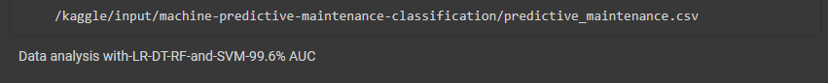

## # Importing necessary libraries

import numpy as np

import pandas as pd

import seaborn as sns

import matplotlib.pyplot as plt

import warnings

warnings.filterwarnings("ignore")

pd.set_option("display.max_columns",None)

pd.set_option("display.max_rows",None)

## # Reading the dataset

df=pd.read_csv("../input/machine-predictive-maintenance-classification/predictive_maintenance.csv")

df = df.drop(["UDI","Product ID"],axis=1)

df.sample(6).style.set_properties(

    **{

        'background-color': 'Brown',

        'color': 'white',

        'border-color': 'White'

    })

## Converting temperature in centigrate from Kelvin [1 K = -272.15 °C  ]

df["Air temperature [K]"] = df["Air temperature [K]"] - 272.15

df["Process temperature [K]"] = df["Process temperature [K]"] - 272.15

# Renaming temperature in Centigrate(°C) from Kelvin (K)

df.rename(columns={"Air temperature [K]" : "Air temperature [°C]","Process temperature [K]" : "Process temperature [°C]"},inplace=True)

df["Temperature difference [°C]"] = df["Process temperature [°C]"] - df["Air temperature [°C]"]

df.sample(5)

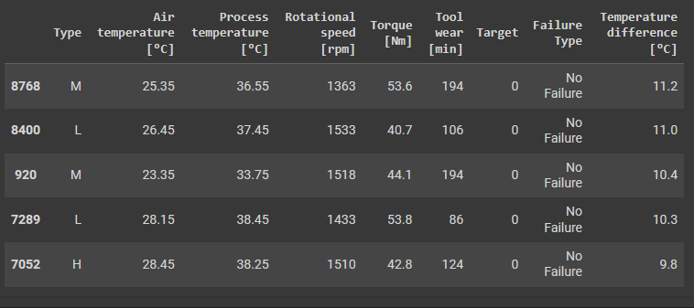

display(df.shape)

display(df.size)



df.info()

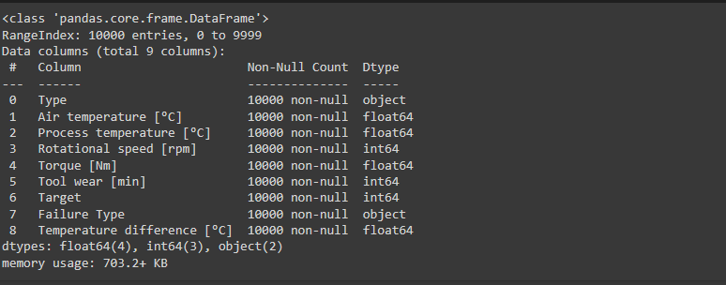

df.describe().style.background_gradient(cmap="magma")

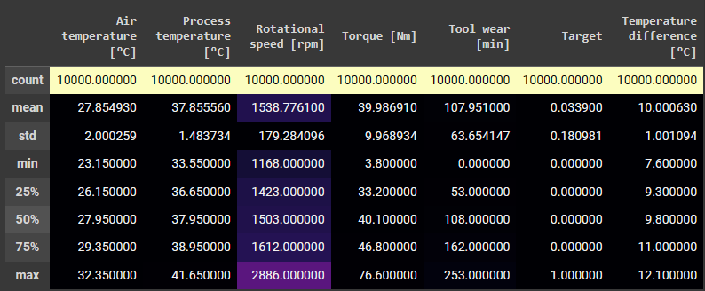

## # Exploratory Data Analysis

# Visualizing missing values

import missingno as msno

msno.matrix(df, figsize=(18,5), fontsize=12, color=(1, 0.38, 0.27));

plt.xticks(rotation=25);

## # Visualizing distributions

sns.displot(data=df, x="Air temperature [°C]", kde=True, bins = 100,color = "red", facecolor = "yellow",height = 5, aspect = 3.5);

sns.displot(data=df, x="Process temperature [°C]", kde=True, bins = 100,color = "red", facecolor = "lime",height = 5, aspect = 3.5);

sns.displot(data=df, x="Temperature difference [°C]", kde=True, bins = 100,color = "blue", facecolor = "DeepPink",height = 5, aspect = 3.5);

## # Exploring categorical variables

for col in df[['Type','Target','Failure Type']]:

    print(df[col].value_counts())

    print("****"*8)

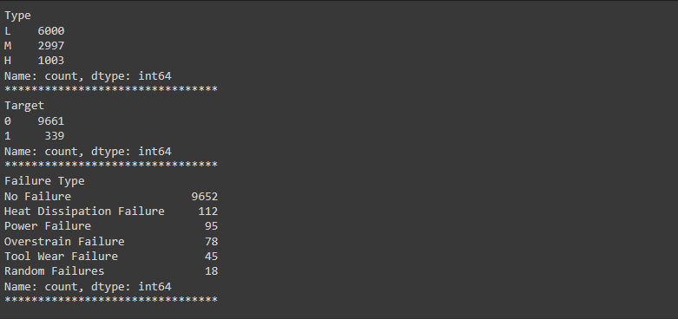

## # Visualizing categorical variables

ax = plt.figure(figsize=(18,6))

ax = plt.subplot(1,2,1)

ax = sns.countplot(x='Type', data=df)

ax.bar_label(ax.containers[0])

plt.title("Type", fontsize=20,color='Red',font='Times New Roman')

ax =plt.subplot(1,2,2)

ax=df['Type'].value_counts().plot.pie(explode=[0.1, 0.1,0.1],autopct='%1.2f%%',shadow=True);

ax.set_title(label = "Type", fontsize = 20,color='Red',font='Times New Roman');

ax = plt.figure(figsize=(18,6))

ax = plt.subplot(1,2,1)

ax = sns.countplot(x='Target', data=df)

ax.bar_label(ax.containers[0])

plt.title("Target", fontsize=20,color='Red',font='Times New Roman')

ax =plt.subplot(1,2,2)

ax=df['Target'].value_counts().plot.pie(explode=[0.1, 0.1],autopct='%1.2f%%',shadow=True);

ax.set_title(label = "Target", fontsize = 20,color='Red',font='Times New Roman');

df.head(2)

plt.figure(figsize=(18,7))

sns.scatterplot(data=df, x="Torque [Nm]", y="Rotational speed [rpm]", hue="Failure Type",palette="tab10");

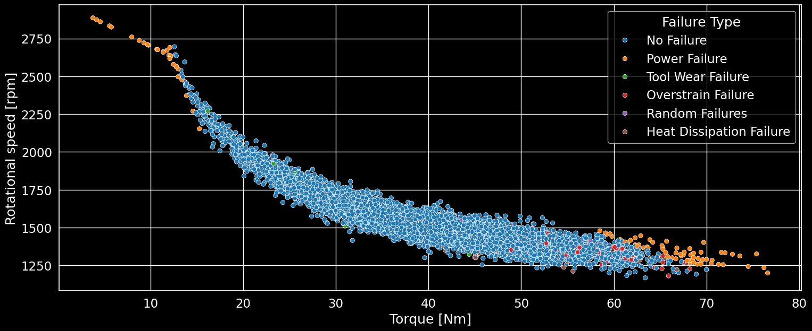

plt.figure(figsize=(18,7))

sns.scatterplot(data=df, x="Torque [Nm]", y="Rotational speed [rpm]", hue="Target",palette="tab10");

plt.figure(figsize=(18,7))

sns.scatterplot(data=df, x="Torque [Nm]", y="Rotational speed [rpm]", hue="Type",palette="tab10");

df.head(2)

## # Visualizing distributions and relationships

#plt.figure(figsize = (15, 6))

#plt.grid()

#sns.swarmplot(df["Torque [Nm]"], df["Failure Type"], hue = df["Failure Type"]);

import statistics

# Plotting histogram and boxplot for Torque [Nm]

def plot_hist(feature):

    fig, ax = plt.subplots(2, 1, figsize=(18, 8))

    sns.histplot(data = df[feature], kde = True, ax = ax[0],color='pink')

    ax[0].axvline(x = df[feature].mean(), color = 'Magenta', linestyle = '--', linewidth = 2, label = 'Mean: {}'.format(round(df[feature].mean(), 3)))

    ax[0].axvline(x = df[feature].median(), color = 'lime', linewidth = 2, label = 'Median: {}'.format(round(df[feature].median(), 3)))

    ax[0].axvline(x = statistics.mode(df[feature]), color = 'brown', linewidth = 2, label = 'Mode: {}'.format(statistics.mode(df[feature])))

    ax[0].legend()

    sns.boxplot(x = df[feature], ax = ax[1],color='pink')

    plt.show()

plot_hist('Torque [Nm]')

## # Plotting histogram and boxplot for Rotational speed [rpm]

def plot_hist(feature):

    fig, ax = plt.subplots(2, 1, figsize=(18, 8))

    sns.histplot(data = df[feature], kde = True, ax = ax[0],color='green')

    ax[0].axvline(x = df[feature].mean(), color = 'red', linestyle = '--', linewidth = 2, label = 'Mean: {}'.format(round(df[feature].mean(), 3)))

    ax[0].axvline(x = df[feature].median(), color = 'orange', linewidth = 2, label = 'Median: {}'.format(round(df[feature].median(), 3)))

    ax[0].axvline(x = statistics.mode(df[feature]), color = 'brown', linewidth = 2, label = 'Mode: {}'.format(statistics.mode(df[feature])))

    ax[0].legend()

    sns.boxplot(x = df[feature], ax = ax[1],color='green')

    plt.show()

plot_hist('Rotational speed [rpm]')

# sns.pairplot(df,hue = "Failure Type");

## # Visualizing distributions and relationships for categorical variables

sns.displot(data=df, x="Torque [Nm]", col="Type", kind="kde");

sns.displot(data=df, x="Rotational speed [rpm]", col="Type", kind="kde");

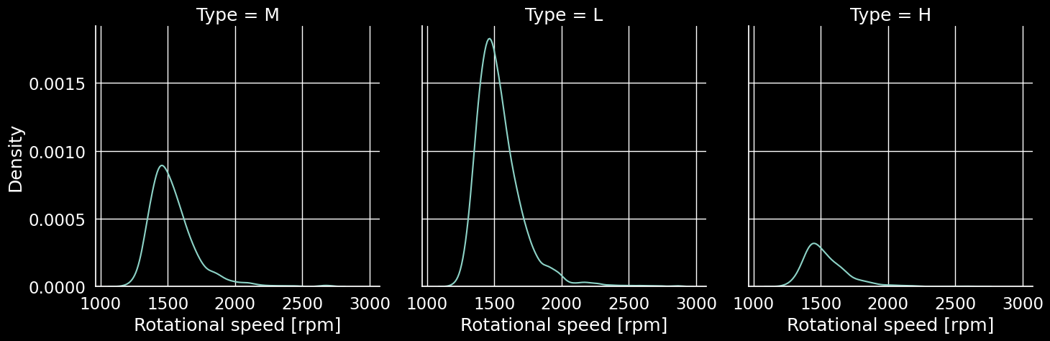

sns.relplot(data=df, x="Torque [Nm]", y="Rotational speed [rpm]", hue="Failure Type",col="Type",palette='tab10');

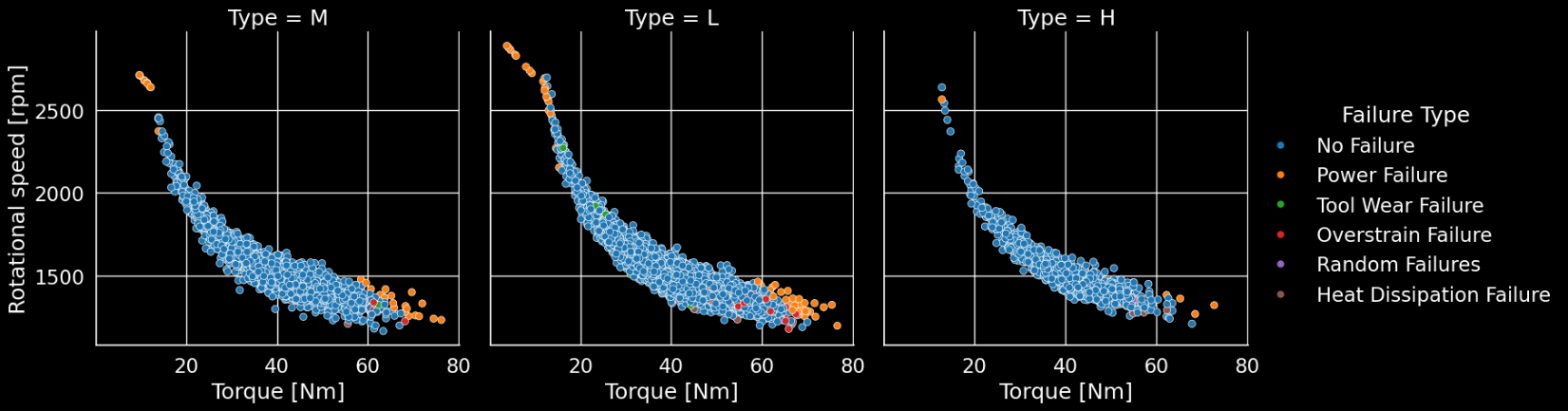

## # Feature Selection

import category_encoders as ce

encoder = ce.OrdinalEncoder(cols=['Type','Failure Type'])

df = encoder.fit_transform(df)

df.head(2)

from sklearn.preprocessing import LabelEncoder

scaler = LabelEncoder()

df['Failure Type'] = scaler.fit_transform(df['Failure Type'])

X = df.drop(columns="Failure Type" , axis=1)

y = df["Failure Type"]

from sklearn.model_selection import train_test_split

X_train,X_test,y_train,y_test = train_test_split(X,y,test_size=0.2,random_state=21)

plt.figure(figsize=(18,5))

ax = sns.countplot(x = y_train, palette = 'tab10')

t= len(y_train)

for p in ax.patches:

    percentage = f'{100 * p.get_height() / t:.1f}%\n'

    x = p.get_x() + p.get_width() / 2

    y = p.get_height()

    ax.annotate(percentage, (x, y), ha='center', va='center')

plt.show()

plt.figure(figsize=(18,5))

ax = sns.countplot(x = y_test, palette = 'tab10')

t= len(y_test)

for p in ax.patches:

    percentage = f'{100 * p.get_height() / t:.1f}%\n'

    x = p.get_x() + p.get_width() / 2

    y = p.get_height()

    ax.annotate(percentage, (x, y), ha='center', va='center')

plt.show()

## # Model Building

# Importing necessary libraries

import matplotlib.pyplot as plt

from sklearn.metrics import accuracy_score, classification_report, confusion_matrix, ConfusionMatrixDisplay

from sklearn.model_selection import train_test_split

from sklearn.linear_model import LogisticRegression

import numpy as np

# Assuming you have X_train, X_test, y_train, y_test defined somewhere before

# If not, define them using train_test_split or another method

logreg = LogisticRegression()

logreg.fit(X_train, y_train)

y_pred_lr = logreg.predict(X_test)

log_train = round(logreg.score(X_train, y_train) * 100, 2)

log_accuracy = round(accuracy_score(y_pred_lr, y_test) * 100, 2)

print("Training Accuracy    :", log_train, "%")

print("Model Accuracy Score :", log_accuracy, "%")

print("\033[1m--------------------------------------------------------\033[0m")

print("Classification_Report: \n", classification_report(y_test, y_pred_lr))

print("\033[1m--------------------------------------------------------\033[0m")

cm = confusion_matrix(y_test, y_pred_lr)

disp = ConfusionMatrixDisplay(confusion_matrix=cm, display_labels=np.unique(y_test))

disp.plot()

plt.title('Confusion Matrix')

plt.show()

## # Decision Tree Classifier

import matplotlib.pyplot as plt

from sklearn.metrics import accuracy_score, classification_report, confusion_matrix, ConfusionMatrixDisplay

from sklearn.model_selection import train_test_split

from sklearn.tree import DecisionTreeClassifier

decision = DecisionTreeClassifier()

decision.fit(X_train, y_train)

y_pred_dec = decision.predict(X_test)

decision_train = round(decision.score(X_train, y_train) * 100, 2)

decision_accuracy = round(accuracy_score(y_pred_dec, y_test) * 100, 2)

print("Training Accuracy    :", decision_train, "%")

print("Model Accuracy Score :", decision_accuracy, "%")

print("\033[1m--------------------------------------------------------\033[0m")

print("Classification_Report: \n", classification_report(y_test, y_pred_dec))

print("\033[1m--------------------------------------------------------\033[0m")

cm = confusion_matrix(y_test, y_pred_dec)

disp = ConfusionMatrixDisplay(confusion_matrix=cm, display_labels=np.unique(y_test))

disp.plot()

plt.title('Confusion Matrix')

plt.show()

## # Random Forest Classifier

from sklearn.ensemble import RandomForestClassifier

random_forest = RandomForestClassifier(n_estimators=100)

random_forest.fit(X_train, y_train)

y_pred_rf = random_forest.predict(X_test)

random_forest_train = round(random_forest.score(X_train, y_train) * 100, 2)

random_forest_accuracy = round(accuracy_score(y_pred_rf, y_test) * 100, 2)

print("Training Accuracy    :", random_forest_train, "%")

print("Model Accuracy Score :", random_forest_accuracy, "%")

print("\033[1m--------------------------------------------------------\033[0m")

print("Classification_Report: \n", classification_report(y_test, y_pred_rf))

print("\033[1m--------------------------------------------------------\033[0m")

cm = confusion_matrix(y_test, y_pred_rf)

disp = ConfusionMatrixDisplay(confusion_matrix=cm, display_labels=np.unique(y_test))

disp.plot()

plt.title('Confusion Matrix')

plt.show()

## # Support Vector Machines Classifier

from sklearn.svm import SVC

svc = SVC()

svc.fit(X_train, y_train)

y_pred_svc = svc.predict(X_test)

svc_train = round(svc.score(X_train, y_train) * 100, 2)

svc_accuracy = round(accuracy_score(y_pred_svc, y_test) * 100, 2)

print("Training Accuracy    :", svc_train, "%")

print("Model Accuracy Score :", svc_accuracy, "%")

print("\033[1m--------------------------------------------------------\033[0m")

print("Classification_Report: \n", classification_report(y_test, y_pred_svc))

print("\033[1m--------------------------------------------------------\033[0m")

cm = confusion_matrix(y_test, y_pred_svc)

disp = ConfusionMatrixDisplay(confusion_matrix=cm, display_labels=np.unique(y_test))

disp.plot()

plt.title('Confusion Matrix')

plt.show()

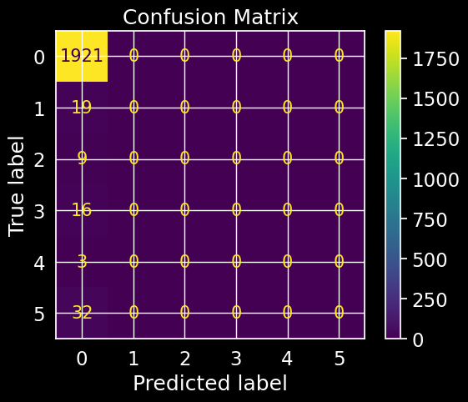

## # Creating a summary of model performances

models = pd.DataFrame({

    'Model': [

        'Support Vector Machines', 'Logistic Regression', 'Random Forest',

        'Decision Tree'

    ],

    'Training Accuracy':

    [log_train, svc_train, decision_train, random_forest_train],

    'Model Accuracy Score': [

        log_accuracy, svc_accuracy, decision_accuracy, random_forest_accuracy

    ]

})

pd.set_option('display.precision', 2)

styles = [

    dict(selector="th", props=[("font-family", "Lucida Calligraphy"), ("color", "LightGreen"), ("font-size", "15px")])

]

models_sorted = models.sort_values(by='Model Accuracy Score', ascending=False)

styled_table = models_sorted.style.background_gradient(cmap='coolwarm').set_table_styles(styles)

styled_table

## # Displaying some predictions

prediction1 = random_forest.predict(X_test)

print(prediction1)



cross_checking = pd.DataFrame({'Actual' : y_test , 'Predicted' : prediction1})

cross_checking.sample(5).style.background_gradient(

        cmap='coolwarm').set_properties(**{

            'font-family': 'Lucida Calligraphy',

            'color': 'LigntGreen',

            'font-size': '15px'

        })

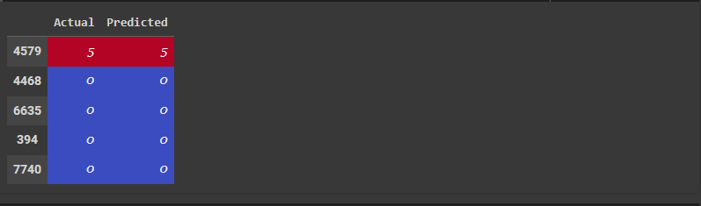

# Conclusion.

The Random Forest Classifier demonstrates the highest accuracy among the models tested, achieving an accuracy score of 99.6%. The classification report provides insights into the precision, recall, and F1-score for each class. Overall, the predictive maintenance classification model shows promising results in accurately identifying machine failure types based on operational features. The distribution of temperature differences reveals a wide range, indicating diverse operating conditions. Among the categorical variables, three types are present, with "Type C" being the most common. Regarding the targets, two types exist, with "Target B" holding a slight majority. Additionally, an imbalance is observed in the failure types, with certain categories occurring more frequently than others.

**Visualizations**: Count and pie plots provide insights into the distribution of types and targets, highlighting the predominance of specific categories. Scatter plots offer an understanding of the relationships between torque, rotational speed, and failure type or target. While some clustering is evident, there's no clear separation observed.

**Statistical Analysis**: Histograms and box plots depict the distributions and central tendencies of torque and rotational speed, aiding in the identification of potential outliers.

**Feature Engineering and Selection**: Categorical variables were encoded to facilitate model training. Further analysis could involve evaluating the importance of each feature to enhance predictive performance.

**Model Building and Evaluation**: Logistic Regression achieved moderate accuracy but may struggle with the complexity of the data. On the other hand, Decision Tree and Random Forest models exhibited higher accuracy, indicating their potential to capture complex relationships. Although Support Vector Machines performed decently, parameter tuning might be necessary for improved performance.

In conclusion, Considering the trade-offs between accuracy, interpretability, and computational complexity, the Random Forest model emerges as the best performer. To enhance predictive performance, further refinement of the Random Forest model, potentially through hyperparameter tuning or ensemble methods, is recommended. Additionally, exploring additional features, refining encoding strategies, or incorporating domain-specific knowledge could lead to more robust models.